# Product Outline

## GI Bill Comparison Tool – Specialized Mission Filter

## Overview

We plan to modify the specialized mission filter section of the GI Bill Comparison Tool to make it prominent and accessible on the CT homepage.

## Problem Statement

After a search is enabled, the specialized mission filter will be moved below the search tabs on the CT home page, giving the filter options greater prominence just above the search results list. The accordion component will additionally provide descriptions of each specialized mission.

## Desired User Outcomes

1. *Why would a user want to use this?*
   * The specialized mission filter allows veterans to select institutions from your search results that meet specific criteria. You can select a specialized mission type from your search results by pressing the item’s checkbox to select.
   * Our goal is to provide more detail about what each specialized mission consists of by providing a brief description of the filter.
2. *With this problem solved, what should users be able to do/achieve that they couldn’t before?*
   * This gives veterans and users a better sense of what school type filters they want to apply to their search results.

## Desired Business Outcomes

1. *Why would your business want this to exist?*
   * Allows users to specify specialized institutions, with descriptions. A capability that they would not have otherwise.
2. *With this problem solved, what should users be able to do/achieve that they couldn’t before?*
   * *Users would have specialized mission filter descriptions readily available via accordion dropdown controls.*

## Measuring Success

1. *What data (qual or quant) will you look at to understand if your initial set of functionalities is meeting your desired user and business outcomes, and not bringing about the undesired outcomes?*
   * *We will be conducting usability studies to gather metrics.*

## Launch Strategy

1. *How are veterans and others using this product going to know it exists?*
2. *What marketing, outreach, or communications are necessary for this product to be successful?*

## Launch Dates

* *Target launch date:* TBD
* *Actual launch date:* TBD

## Screenshots

* Graphical user interface, text, application

  Description automatically generated***Before:***

Figure Comparison Tool: Search by Name option

Figure Filtering your results

* ***After:*** [**Link to Sketch file**](https://sketch.com/s/7bf24c0f-14f0-4efd-8891-9937ed02fca8)**­**

**Desktop view**

Figure Design proposal: Search bar and specialized mission definitions accordion

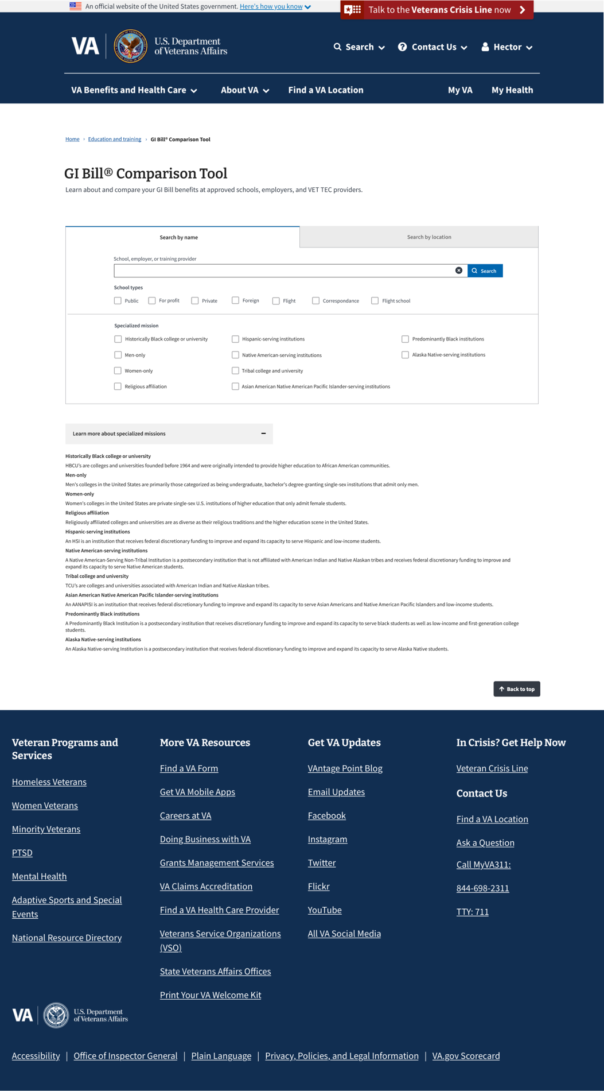

Figure Design proposal: List view of specialized mission definitions, accordion drop-down